GSEA analysis
Gene Set Enrichment Analysis (GSEA) is a method used to determine whether a predefined group of genes—such as a barrier-related gene set[1]—is significantly overrepresented at the top or bottom of a ranked list of all genes from an experiment. This ranking is typically based on a metric like the signed -log(p-value), which captures both the strength and direction of gene expression changes between two conditions (e.g., normoxia vs. hyperoxia or wild-type vs. Emp2 knockout in mouse retina samples). The Normalized Enrichment Score (NES) quantifies how strongly the gene set is enriched, adjusting for gene set size. A positive NES indicates the genes are generally upregulated, while a negative NES suggests they are downregulated.
Global_norvsOIR (Normoxia vs. OIR Comparison)
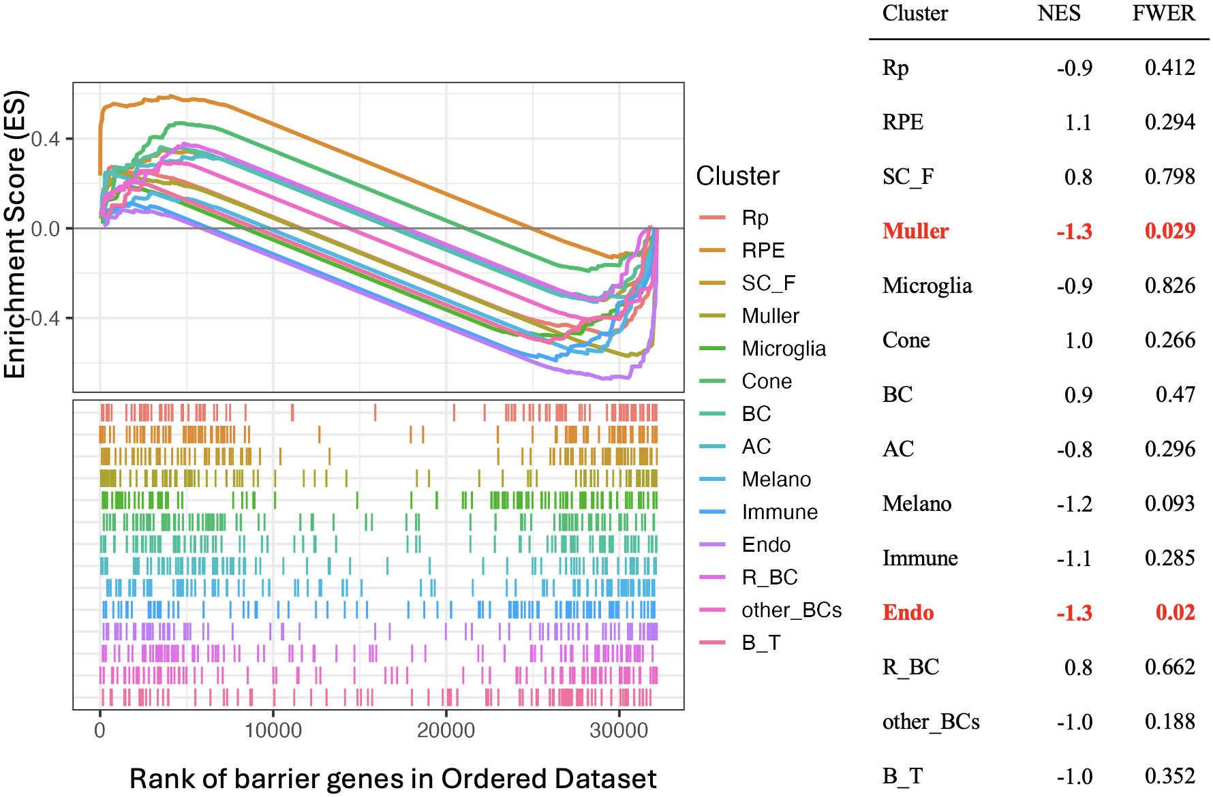

In our analysis, we performed Gene Set Enrichment Analysis (GSEA) for each cell cluster to assess whether genes in the predefined barrier-related gene set were enriched among those differentially expressed between normoxia and OIR conditions. Notably, the Müller (Muller) and endothelial (Endo) clusters showed statistically significant negative enrichment scores, indicating a downregulation of barrier-related genes in response to OIR.

Global_WTvsEmp2ko (Wild-Type vs. Emp2 Knockout Comparison)
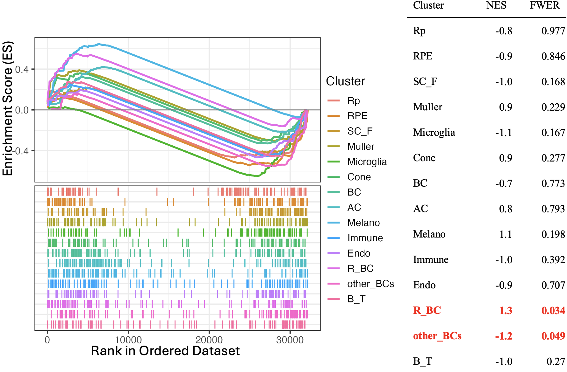

GSEA comparing wild-type and Emp2 knockout conditions revealed distinct enrichment patterns across cell clusters. Barrier-related genes were positively enriched in cluster R_BC, indicating upregulation in the knockout, while negative enrichment in cluster other_BCs.

WTvsEmp2ko_nor (Wild-Type vs. Emp2 Knockout Comparison in Normoxia)
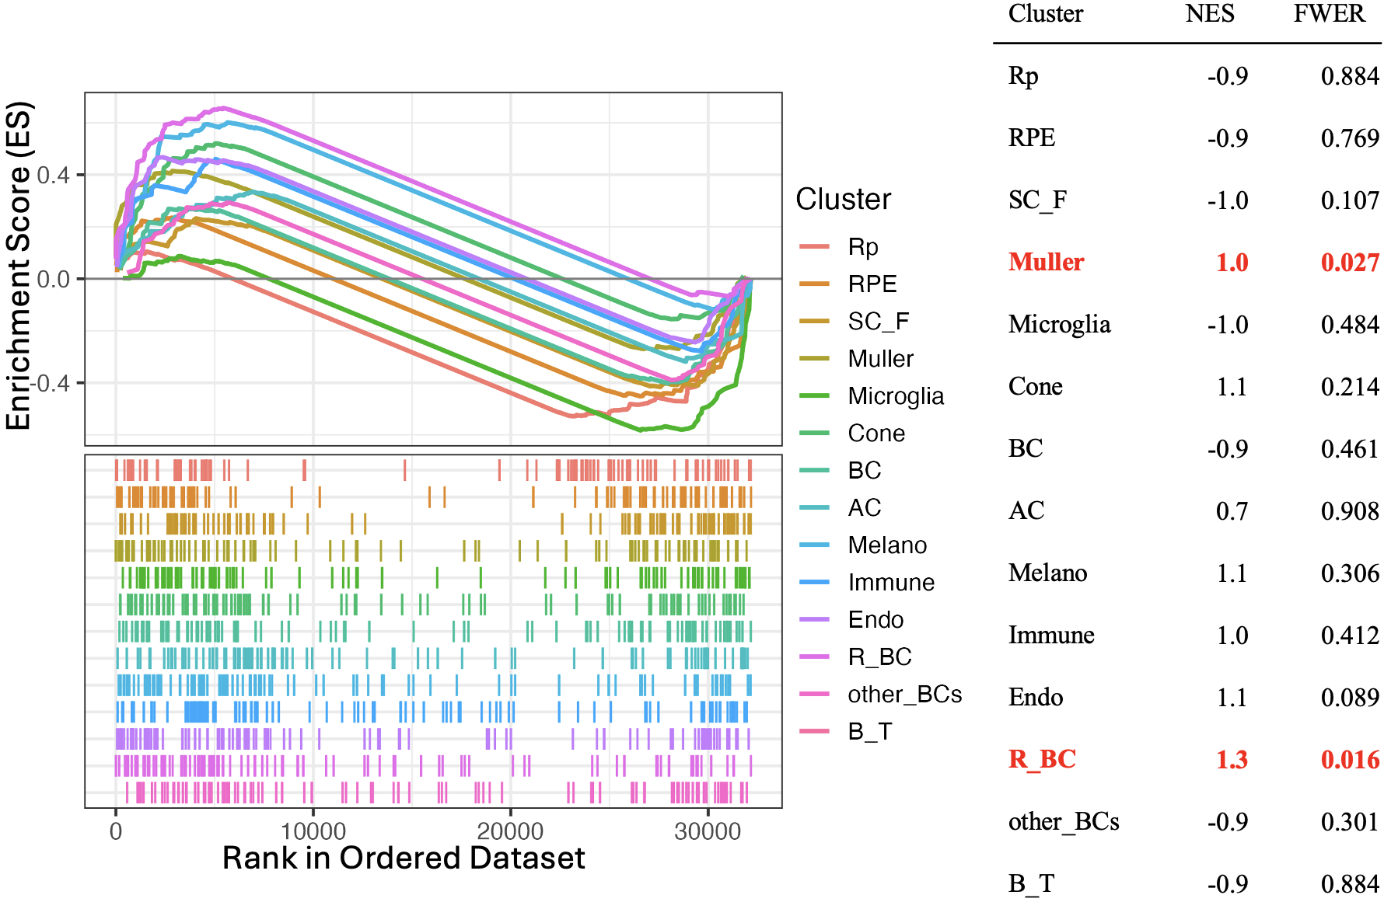

Under normoxia conditions, GSEA revealed upregulation of barrier-related genes in the Emp2 knockout, with positive enrichment observed in clusters like Muller and R_BC.

WT_norvsOIR (Normoxia vs. OIR Comparison in Wild-Type)
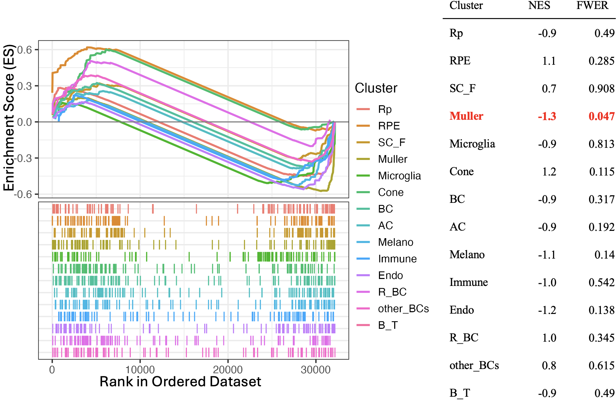
In wild-type samples, GSEA comparing normoxia and OIR conditions showed negative enrichment of barrier-related genes in the Muller cluster, indicating their downregulation in response to OIR.

Emp2ko_norvsOIR (Normoxia vs. OIR Comparison in Emp2 Knockout)
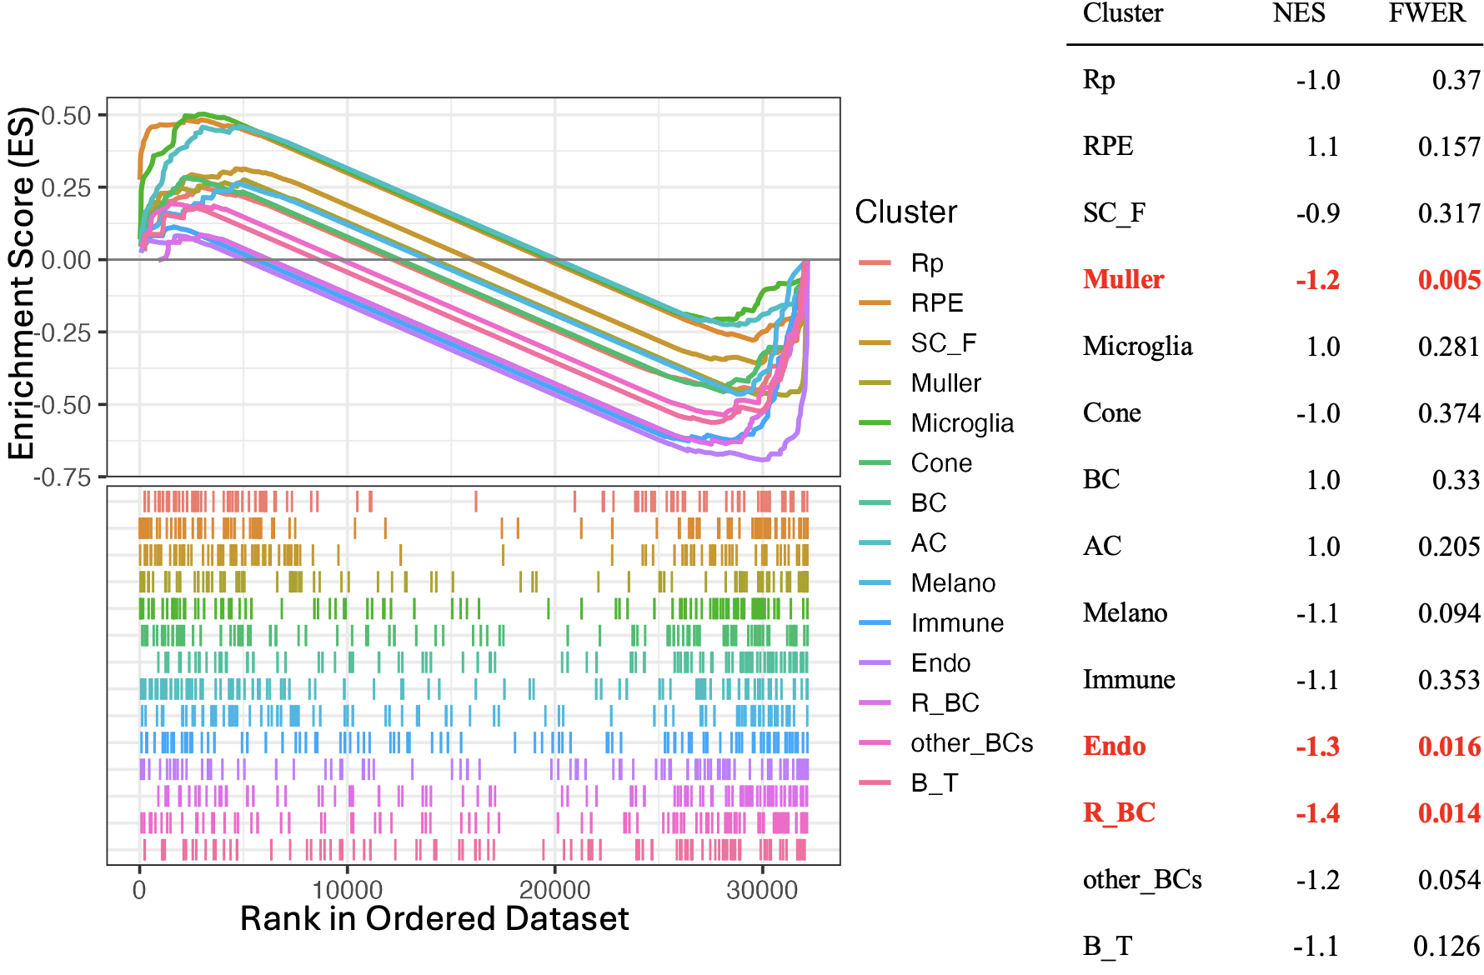
In the Emp2 knockout background, GSEA showed distinct barrier-related gene expression changes between normoxia and OIR, with negative enrichment in Muller, Endo, and R_BC clusters, indicating downregulation under OIR.

Reference
1. Saverimuttu, S.C.C., et al., Gene Ontology curation of the blood-brain barrier to improve the analysis of Alzheimer's and other neurological diseases. Database (Oxford), 2021. 2021.

